

EAST STAFFORDSHIRE FAMILY SUPPORT SERVICE
HARVEY GIRLS/ DADS4DADS/YOUTH

OPERATIONS MANAGER

Salary: £ 33,500 - £ 37,000 per annum (dependent on experience.)
Hours: 37.5 hours per week. (We are committed to attracting the best talent and recognise that flexibility matters. Although this position is advertised as full-time, we would be happy to consider part-time applications for the right person).
Contract: Permanent.
Location: East Staffordshire & surrounding areas.
Annual Leave: 30 days including Bank Holidays.
Pension: Employer Contribution.

Can You Help Us Change Lives?
East Staffordshire Family Support Service is seeking an inspirational, ambitious, and compassionate Operations Manager to help lead our growing organisation and strengthen the support we provide to children, young people, parents, and families across East Staffordshire. This is more than an operational role. This is an opportunity to shape the future of an organisation that believes every person deserves access to support, opportunity and someone who believes in them.

About East Staffordshire Family Support Service
Our services focus on building stronger families by supporting parents, empowering young people, and creating positive changes within our community.

About our CEO, Ian North.

Ian North is an experienced Chief Executive, board director and community leader with a strong background in housing, education, charity, and local government. As CEO of East Staffordshire Family Support Service, he leads services supporting children, families, and communities. He has held senior governance roles across major housing organisations, chaired school governors and held elected positions in local government. Known for his expertise in strategic leadership, governance and financial stewardship, Ian is committed to using strong leadership and partnerships to deliver lasting community impact.



Have you got the energy, drive, and personality to

help us change lives?

We Are Looking for Someone Who:

- Is passionate about improving outcomes for children, young people, parents, and families.
- Has strong operational leadership experience and can lead day-to-day operations across all services.
- Understands charity governance, safeguarding and compliance standards and how to ensure that these are maintained.
- Can manage budgets, support financial sustainability and organisational performance.
- Has a track record of successful bid writing, fundraising, and income generation activities.
- Can build strong relationships with community partners and service users and is willing to be visible within our services and communities.
- Can develop new services and partnerships whilst delivering our business plan objectives and organisational priorities.
- Can monitor KPIs, outcomes and performance data.
- Who has excellent communication and report-writing skills and can produce reports for Trustees, funders, and stakeholders.
- Can oversee marketing, website, and social media activities.
- Is confident leading and developing teams whilst managing staff, volunteers, and performance.

Why Join East Staffordshire Family Support Service?
You will:

- Work directly with the CEO and the Trustee Board.
- Influence the future direction of a growing organisation.
- Make a genuine difference to local families and communities.
- Develop services that create lasting impact.
- Join a passionate team committed to changing lives.

Join Us

- Bring your commitment to helping children, young people, parents, and families thrive.

- Bring your energy.

- Bring your experience.

- Bring your ideas.

Role Purpose

Reporting directly to the CEO and working closely with the Trustee Board, the Operations Manager will provide strategic and operational leadership across all our services. In this senior role you will be responsible for ensuring effective service delivery, organisational growth, financial sustainability, governance compliance, safeguarding standards, and the achievement of our business plan objectives. The postholder will combine operational management with hands-on community engagement, helping to ensure that services remain responsive to the needs of children, young people, parents, and families across East Staffordshire.
Key Responsibilities

Strategic Leadership & Governance
- Support the CEO and Trustee Board in delivering the organisation's strategic vision and business plan objectives.
- Provide regular operational and performance reports to the CEO and Trustees.
- Support charity governance, compliance, risk management, and regulatory requirements.
- Develop and maintain policies, procedures, and organisational systems.
- Ensure clear accountability across all operational functions.

Service Delivery & Development
- Oversee the delivery of our sessions including Harvey Girls, Dads4Dads and our Youth Group.
- Ensure services consistently achieve agreed KPIs, quality standards and outcomes.
- Lead service improvement initiatives using performance data and client feedback.
- Identify opportunities for service growth, innovation, and development.
- Maintain a visible presence within frontline services and community activities.

Safeguarding & Quality Assurance
- Act as Safeguarding Lead, ensuring best practice, compliance, training, and monitoring.
- Ensure services operate within safeguarding, health and safety, data protection, and confidentiality requirements.
- Monitor quality standards and implement continuous improvement measures.
- Use performance and impact data to inform strategic decision-making.
- Financial management and income generation.
- Develop, manage, and monitor operational budgets.
- Support the financial sustainability of the organisation through effective resource management.
- Identify new funding opportunities, partnerships, and income streams.
- Lead the preparation and submission of high-quality grant applications, funding bids, and tenders.
- Maintain a funding pipeline and support the delivery of funded outcomes.

People Management
- Lead, manage and develop frontline staff and volunteers.
- Implement effective performance management systems, supervision, and appraisal processes.
- Foster a positive, supportive, and high-performing organisational culture.
- Support staff development, training, and wellbeing.

Communication, Engagement & Marketing
- Develop meaningful client engagement processes that ensure service users influence service delivery.
- Produce reports for the CEO, Trustee Board, funders, and stakeholders.
- Lead marketing and promotional activity to raise awareness of our services.
- Maintain and oversee website content and social media platforms, including Facebook.
- Build positive relationships with partners, funders, community organisations, and stakeholders.

Community & Frontline Involvement
- Engage directly with children, young people, parents, and families who attend our services.
- An expectation to carry a caseload as an experienced practitioner.
- Support community events, outreach activities, and service delivery.
- Gather feedback from service users to inform development and improvement.
- Champion the organisation's mission and values throughout the community.

This is an exciting opportunity for you to join a well-established local charity that has been delivering quality support, in various ways, to reach’ families for over twenty-three years. We improve the outcomes of those who we support through our ‘Four Pillars to Transformation Approach.’
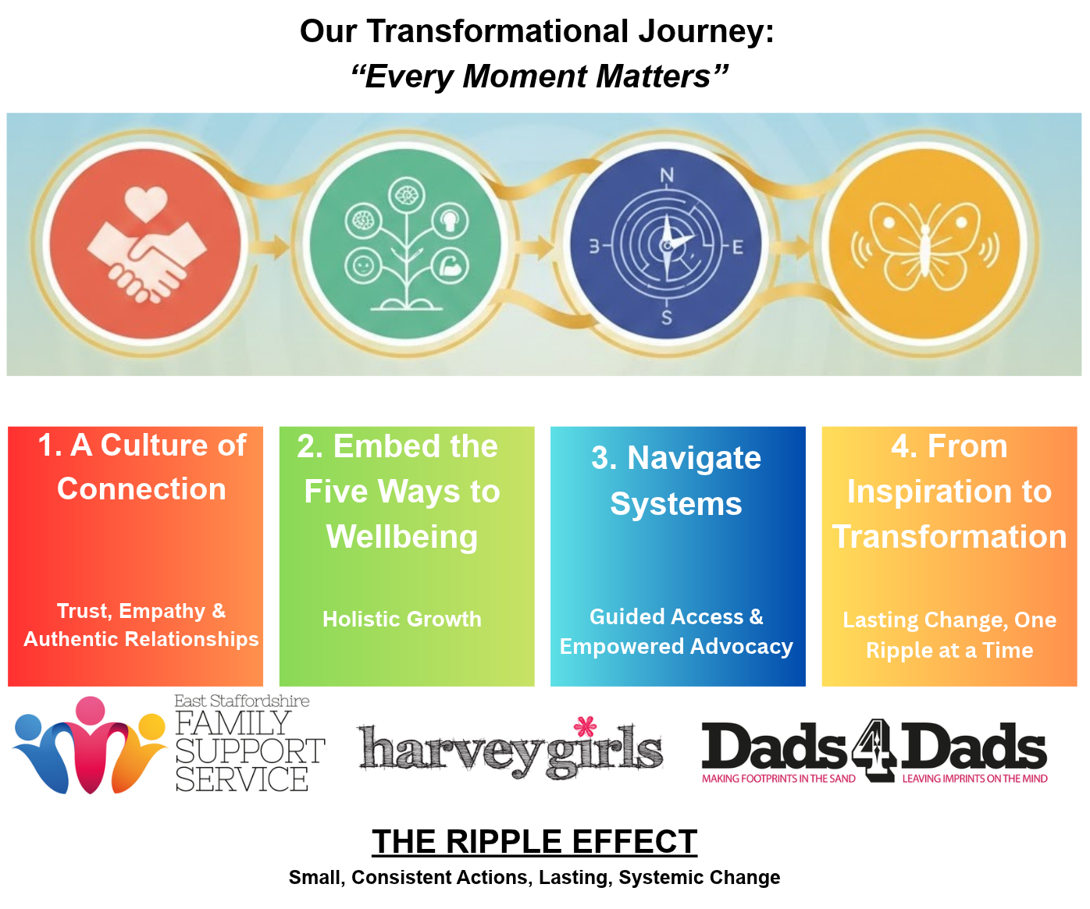

Essential Criteria

Qualifications

- Degree-level qualification or equivalent relevant experience.
- Evidence of continued professional development.
- Safeguarding training relevant to children, young people, and vulnerable adults.
- Full UK driving licence and access to a vehicle.

Leadership & Management

- Minimum 3 years' experience in operational, service, project, or leadership management.
- Experience managing, motivating, supervising, and developing staff and/or volunteers.
- Experience implementing performance management, supervision, and appraisal processes.
- Ability to manage multiple priorities, projects, and deadlines effectively.

Funding & Income Generation

- Proven success in researching, developing, and submitting funding applications, grants, or tenders.
- Experience identifying funding opportunities and developing funding pipelines.
- Ability to build strategic partnerships to support organisational sustainability and growth.

Governance, Compliance & Safeguarding

- Experience supporting governance and compliance processes.
- Ability to prepare reports for trustees, boards, and senior leaders.
- Experience implementing policies and procedures.
- Strong understanding of safeguarding responsibilities and practical application.
- Knowledge of risk management, health and safety, confidentiality, and data protection requirements.

Service Delivery & Development

- Experience managing or supporting community, family, youth, or voluntary sector services.
- Ability to monitor performance against targets, outcomes, and KPIs.
- Experience in service improvement, development, and evaluation.
- Skilled in collecting, analysing, and reporting impact and performance data.

Communication & Engagement

- Strong stakeholder management and relationship-building skills.
- Experience working with funders, partners, community organisations, and service users.
- Ability to produce high-quality reports, presentations, and written communications.
- Experience in community engagement, partnership working, and organisational promotion.

Knowledge & Skills
Strong knowledge of safeguarding legislation and best practice. Understanding of charity governance and trustee responsibilities.
Knowledge of fundraising, funding, and income generation.
Financial management and budgeting skills.
Excellent written and verbal communication skills.
Strong organisational and time management abilities.
Ability to analyse data and use evidence to inform decision-making.
Competent user of Microsoft Office, databases, websites, and social media platforms.
Ability to work independently and use initiative.

Personal Attributes
Passion for improving outcomes for children, young people, parents, and families.
Inspiring and effective leadership style.
Positive, proactive, and solution-focused approach.
High integrity, professionalism, and accountability.
Resilient and calm under pressure.
Strong attention to detail and commitment to quality.
Flexible and willing to work occasional evenings and weekends.

Collaborative and team oriented.
Confident ambassador for the organisation and its values.

Desirable Criteria

Experience within the charity, community, family support, or youth sector.
Qualification in leadership, management, youth work, community development, or safeguarding.
Experience working directly with trustees or governance boards.
Experience managing contracts and commissioning arrangements.
Experience using CRM, case management, or database systems.
Experience developing and delivering marketing campaigns.
Understanding of local communities and services across East Staffordshire.
Knowledge of outcome measurement frameworks and social impact reporting

Ready to make an impact?
For an informal chat, contact Ian North (CEO) on 07557 529983

To request an application pack, call 01283 533449 or email sarah.watson@harveygirls.co.uk

Be part of a charity where your leadership helps transform lives across East Staffordshire. Apply Today!

Message from the Chief Executive, Ian North
Thank you for your interest in working for East Staffordshire Family Support Service/ Harvey Girls/ Dads4Dads/Youth.

We believe that success begins with the right people. That is why we are looking for passionate, talented individuals who want to make a real impact.

Whether you are an experienced professional or just starting your journey, we offer a dynamic environment where innovation, collaboration, and personal growth thrive.

Join us and be part of a team that values your ideas, supports your ambitions, and helps you build a rewarding career.


Are you ready to take the next step? Let’s shape the future together!



 JOIN OUR TEAM


support@ harveygirls. co.uk




01283 533449

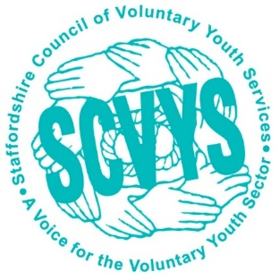

www. facebook. com/ esfss


www. eaststaffordshirefamilysupport. co.uk
















Harvey Girls - 73 Horninglow Road, Burton upon Trent, Staffordshire, DE14 2PT
Registered Charity No: 1142555 Registered Company No: 7533989

